**HOTHOUSE**

**NURSERY**

**MANAGEMENT**

**SYSTEM**

**INDEX**

**1.INTRODUCTION**

1.1 NEED OF SYSTEM

1.2 EXISTING SYSTEM

1.3 PROPOSED SYSTEM

**2.PROJECT DESCRIPTION/DETAILS**

**3.PLATFORM DETAIL**

3.1 INFORMATION

**4.REUIREMENT ANALYSIS**

4.1 FEASIBLITIES STUDIES

4.2 SOFTWARE HARDWARE REQUIREMENTS

**5.DATA DICTIONARY**

**6.SYSTEM DESIGN**

**7.SCREENSHOT OF OUTPUT**

**8.CONCLUSION OF PROJECT**

**9.REFERENCE**

**1.INTRODUCTION**

**1.1 NEED OF SYSTEM**

The project is based on Nursary Management as a part of B.Sc.(Comp. Sci.) Semester II in academic year of 2020-21. The project is developed for Management of Nursary.

Currently all the work in a nursary is managed manually. However, to keep the records of customer, record of plants, information of transaction of plants through manual system is very complicated and not easy to handle. Moreover, the information should be stored in registers, hence paper work is also there. If any of the register is lost then, it causes loss of large amount of important data.

Nursary Management Computer System solves all above problems and provide an easy way to handle all above tasks with use of computer. It also helps us to store these records permanently in the computer. So, there is no chance of loss of information.

Thus, project is developed to meet all these requirements with the use of computerization.

* 1. **EXISTING SYSTEM**

Existing system runs manually, so it is time consuming. All the documentation is done manually. So there are much more chances of data redundancy, data duplication and their is lot of workload on the registrar. So there are always chance of incorrect data because of human errors.

It is very difficult to manage the records of many suppliers and customers. System has to manage each record individually.

Existing system also require much more papers and files work and it is very difficult to maintain such big files and other documents.

**1.3 PROPOSED SYSTEM**

To handle all the subsystems involved in this system are very difficult.

It involves insertion and deletion of plant as well as it removes the plant when we sells it to the customer. All records of these should be kept carefully. Also it involves the entries of suppliers and customers. All the transactions of plants should be noted.

Hence, the simplicity, reliability, consistency and accuracy in the working is required to have computerized system for every process.

**2.PROJECT DETAILS**

The “Nursary Management System” has many sub processes, which includes managing suppliers and plants as well as customer’s record and adding & removing new plants. It also includes the transactions of plants from suppliers/to customers and shop. All these information are stored using permanent memory of computer.

Since, we are using tabular databases to store these records, all paper work is reduced.

**3. PLATFORM DETAILS**

**3.1 INFORMATION**

* **SOFTWARE REQUIREMENTS**
* Operating System : Linux
* Front End Software : Core Java
* Back End Software : Postgresql

**4.REQUIREMENT ANALYSIS**

**4.1 FEASIBLITIES STUDIES**

The success of the system is depend upon how effectively the system is exciting. For the effective and efficient working of the system it should feasible in all the aspects.

* **Preliminary Investigation has three parts :-**
* Request clarification.
* Feasibility study.
* Request approval.
* **Feasibility study :-**

It serves for…

* To estimate rough cost to each possible solution.
* To develop rough cost of possible benefits and drawbacks
* To develop the online of project to be carried out.

**Further three aspects of feasibility study are :-**

**1] Technical Feasibility**

Technical feasibility study is the Hardware and Software requirements of the system. This system has java as a front end and SQL as a back end. The hardware and software requirements are feasible for this system. There is no special equipment that has to buy newly.

**2] Economical Feasibility**

The expense of hardware and software for the system is found to be very cost effective and beneficial for the management. you don’t need to purchase the any special software or hardware from the market, so effectively the cost. No maintenance is required. You can carry it easily to other place. The system gives the status of every trade in the management thus it saves valuable time required for accessing project or requirements.

**3] Operational Feasibility**

The system is user friendly and easy to operate. Hence any persons can operate or use the proposed system as no special kind of training or expertise person will be required.

**4.2 SOFTWARE HARDWARE REQUIREMENTS**

* **HARDWARE REQUIREMENTS**
* Processor of Pentium or above.
* Minimum of 256 MB RAM.
* Minimum of 20 GB Hard disk.
* Monitor.
* Mouse.
* Key Board.
* **SOFTWARE REQUIREMENTS**
* Operating System : Linux
* Front End Software : Core Java
* Back End Software : Postgresql

**5.DATA DICTIONARY**

**DATA ELEMENT DICTIONARY FOR LOGIN TABLE**

|  |  |  |  |  |
| --- | --- | --- | --- | --- |
| Sr.No. | FIELD NAME | TYPE | CONSTRAINT | DESCRIPTION |
| 1. | uname | Text | - | User name for user account of system |
| 2. | pwd | Text | - | Password for user |

**DATA ELEMENT DICTIONARY FOR PLANT TABLE**

|  |  |  |  |  |
| --- | --- | --- | --- | --- |
| Sr.No. | FIELD NAME | TYPE | CONSTRAINT | DESCRIPTION |
| 1. | pid | Integer | Primary Key | Plant registration number |
| 2. | pname | Text | - | Name of respective plant |
| 3. | pdesc | Text | - | Description of plant |
| 4. | fer | Text | - | Fertilizer req. or not for plant |
| 5. | Price | Float | - | Price of plant |
| 6. | qtyavail | Integer | - | Available quantity of plant |

**DATA ELEMENT DICTIONARY FOR CUSTOMER TABLE**

|  |  |  |  |  |
| --- | --- | --- | --- | --- |
| Sr.No. | FIELD NAME | TYPE | CONSTRAINT | DESCRIPTION |
| 1. | cid | Integer | Primary key | Customer registration number |
| 2. | cname | Text | - | Name of customer |
| 3. | Contact | Text | - | Customer’s contact number |

**DATA ELEMENT DICTIONARY FOR PDETAIL TABLE**

|  |  |  |  |  |
| --- | --- | --- | --- | --- |
| Sr.No. | FIELD NAME | TYPE | CONSTRAINT | DESCRIPTION |
| 1. | pid | Integer | - | Plant registration number |
| 2. | pname | Text | - | Name of respective plant |
| 3. | pdesc | Text | - | Description of plant |
| 4. | fer | Text | - | Fertilizer req. or not for plant |
| 5. | tplants | Integer | - | Total number of plants |
| 5. | prate | Float | - | Rate of plant |
| 6. | pdate | Date | - | Date of plant Purchased |
| 7. | tamt | Float | - | Total amount |
| 8. | Sname | Text | - | Supplier’s name |
| 9. | Scontact | Text | - | Supplier’s contact number |

**DATA ELEMENT DICTIONARY FOR SUPPLIER TABLE**

|  |  |  |  |  |
| --- | --- | --- | --- | --- |
| Sr.No. | FIELD NAME | TYPE | CONSTRAINT | DESCRIPTION |
| 1. | Sid | Integer | Primary key | Supplier registration number |
| 2. | sname | Text | - | Nmae of supplier |
| 3. | scontact | Text | - | Supplier’s contact number |
| 4. | Sadd | Text | - | Address of supplier |

**DATA ELEMENT DICTIONARY FOR SDETAIL TABLE**

|  |  |  |  |  |
| --- | --- | --- | --- | --- |
| Sr.No. | FIELD NAME | TYPE | CONSTRAINT | DESCRIPTION |
| 1. | pid | Integer | - | Plant registration number |
| 2. | pname | Text | - | Name of respective plant |
| 3. | pdesc | Text | - | Description of plant |
| 4. | fer | Text | - | Fertilizer req. or not for plant |
| 5. | tplants | Integer | - | Total number of plants |
| 5. | prate | Float | - | Rate of plant |
| 6. | sdate | Date | - | Date of plant Sold |
| 7. | tamt | Float | - | Total amount |
| 8. | cname | Text | - | Customer’s name |
| 9. | ccontact | Text | - | Customer’s contact number |

6. SYSTEM DESIGN

**E-R DIAGRAM**

PLANTS

Has

**Nursary**

Supplier

Customer

has

has

**Nursary Management System**

**Nursary Management System**

BILLS

2.UML DIAGRAM

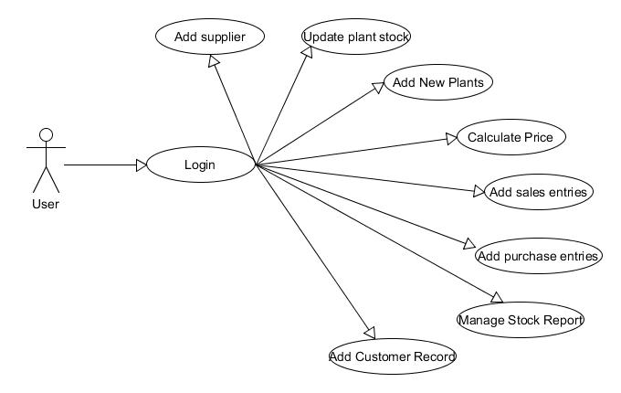

3.ACTIVITY DIAGRAM

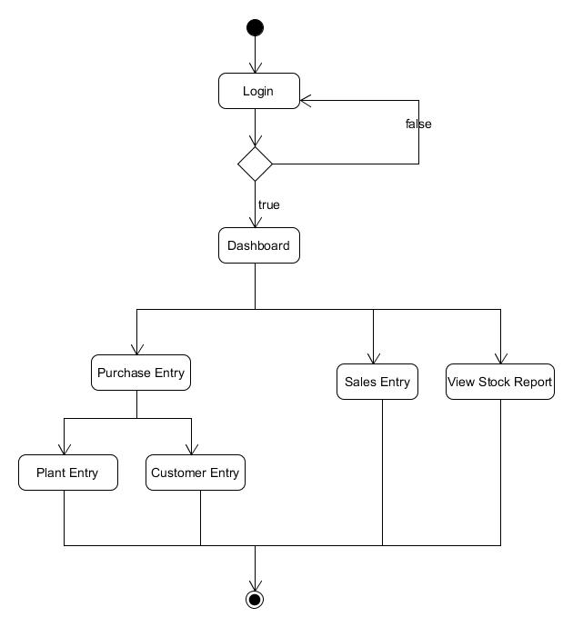

4.CLASS DIAGRAM

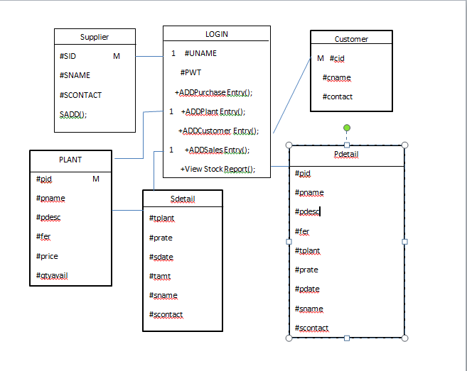

SEQUENCE DIAGRAM

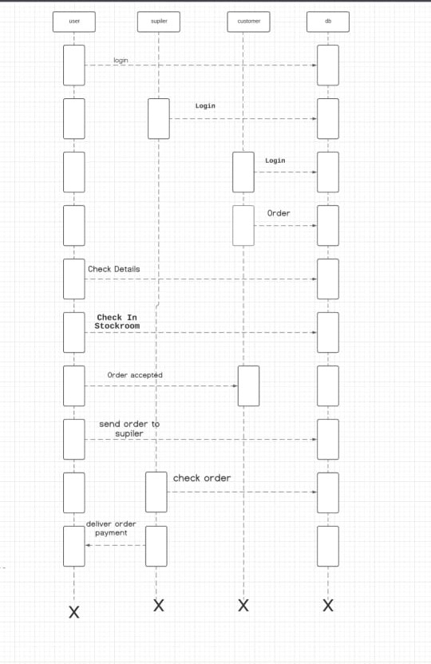

DEPLOYMENT DIAGRAM

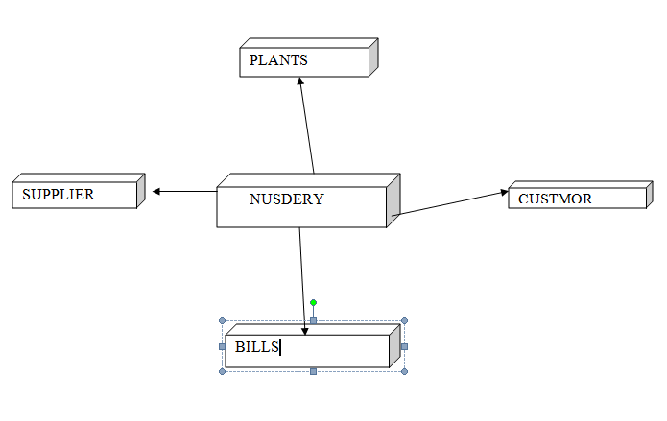

7.SCREENSHOT OF OUTPUT

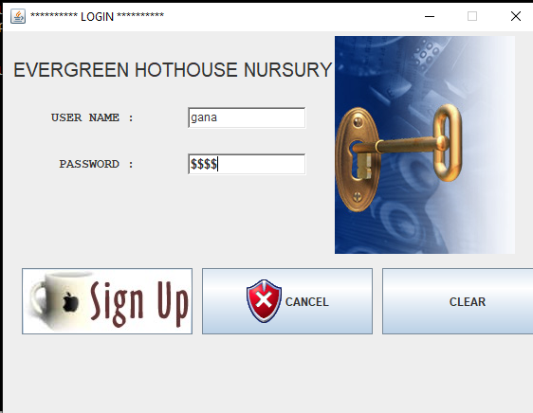

If user-name and password is wrong then software will not execute

Valid Login-name and Password



Valid Login-name and Password

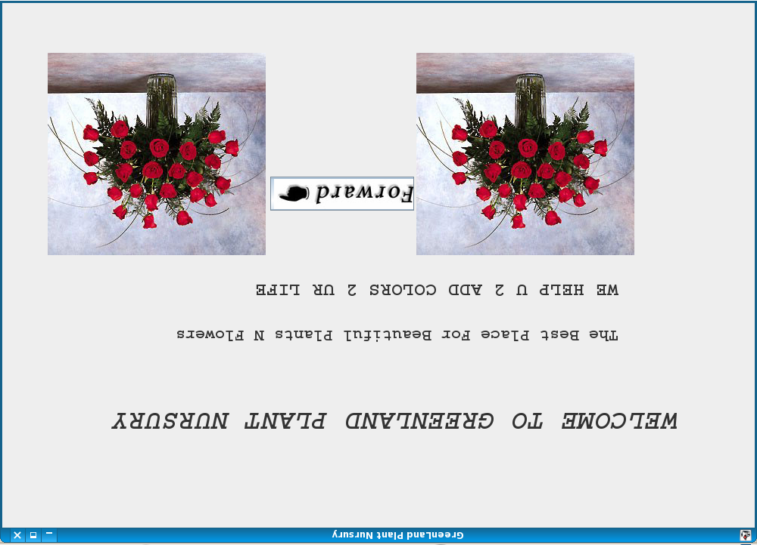

This is Welcome Screen

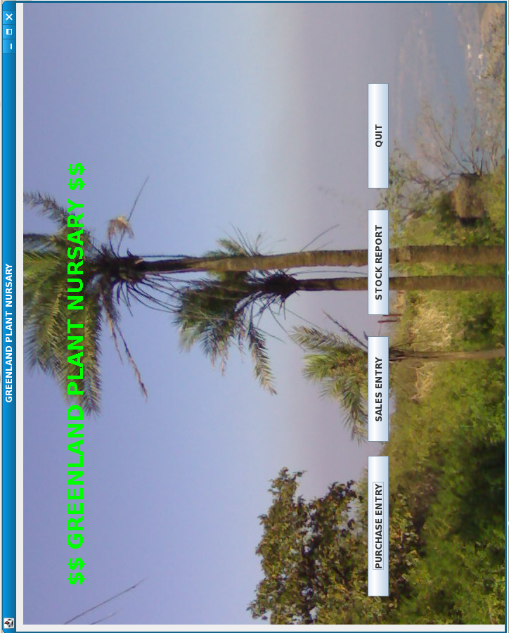

This is main screen of s/w.

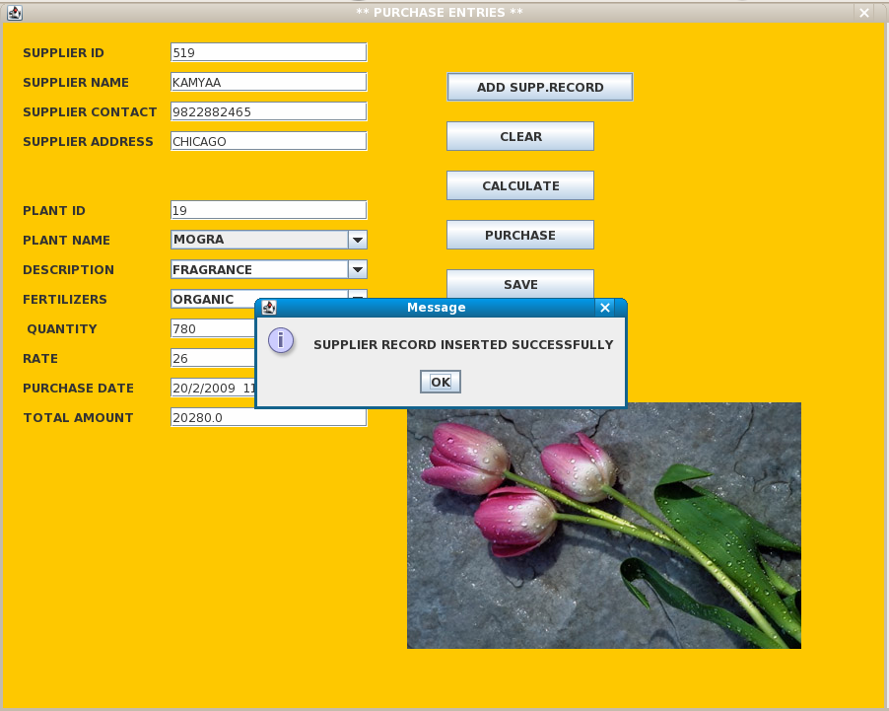

Supplier details added successfully to database

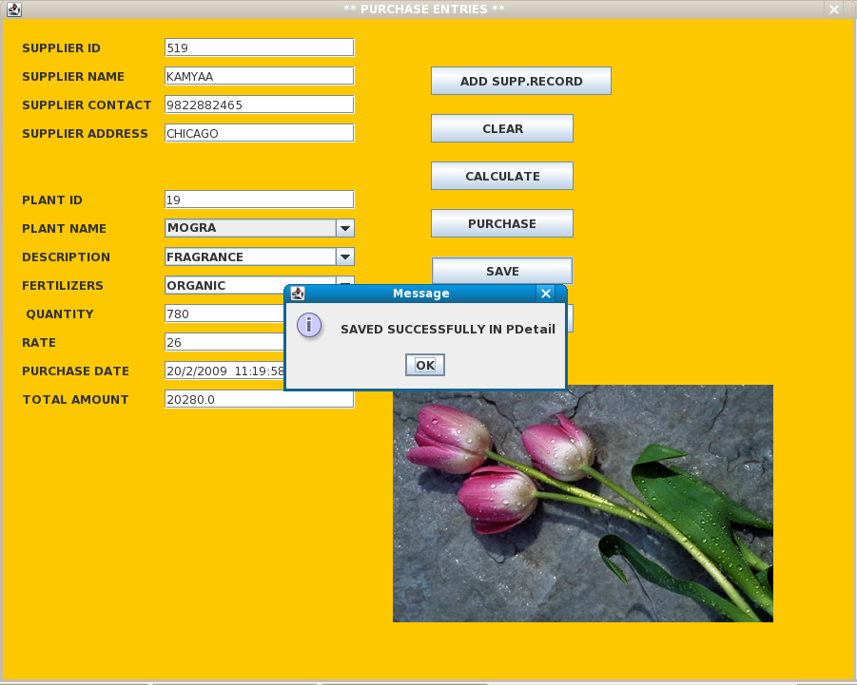

Purchase details added successfully.

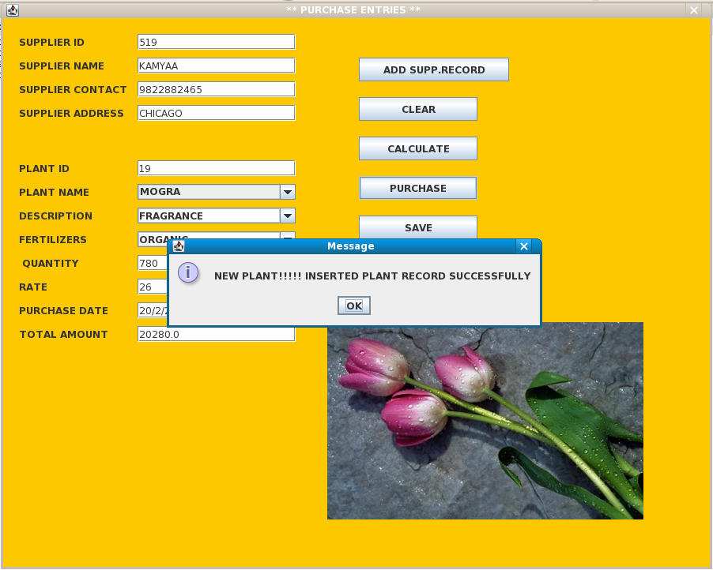

New plant added successfully to Nursary

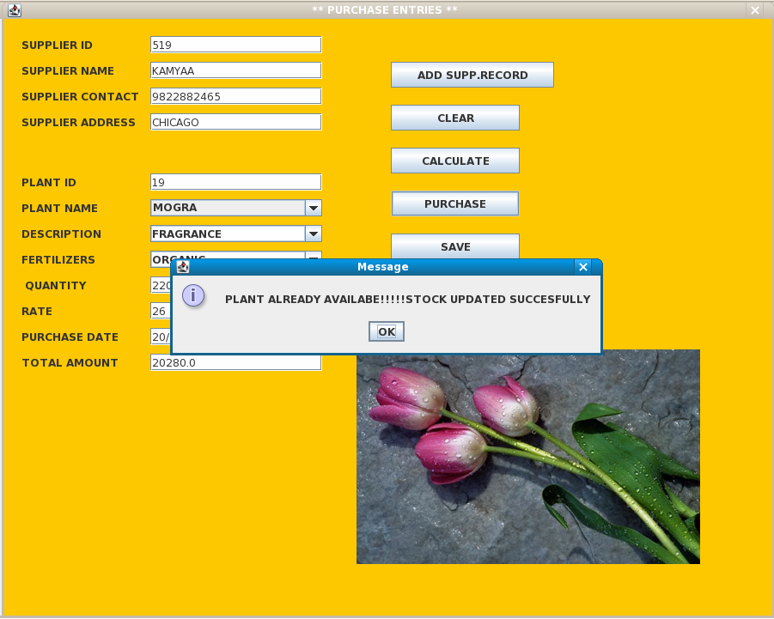

Plant already present. Stock updated successfully

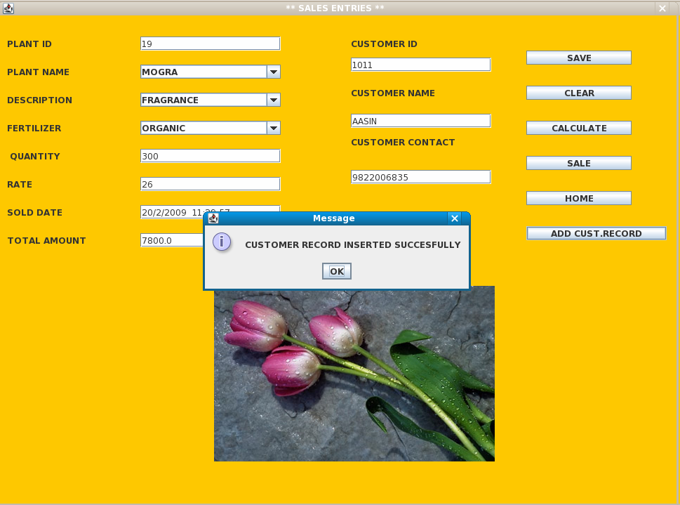

Customer record added to database

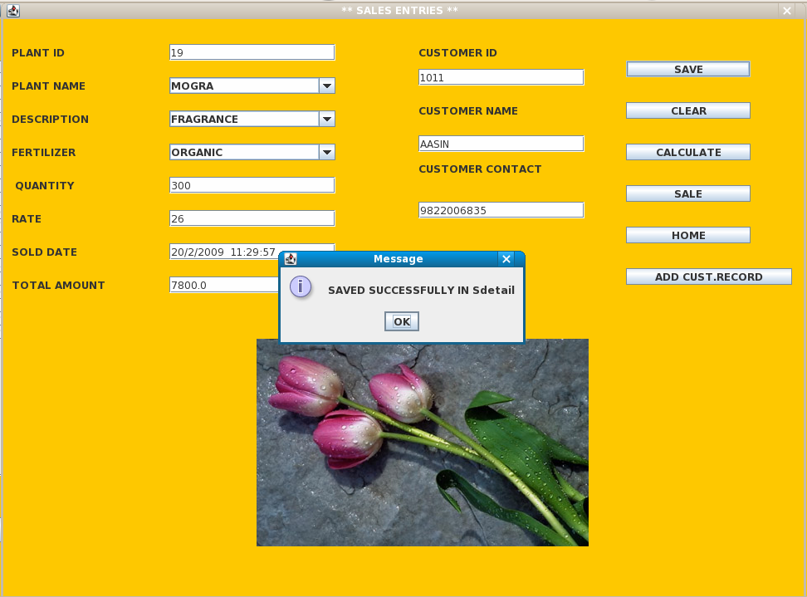

Sale details added successfully to database

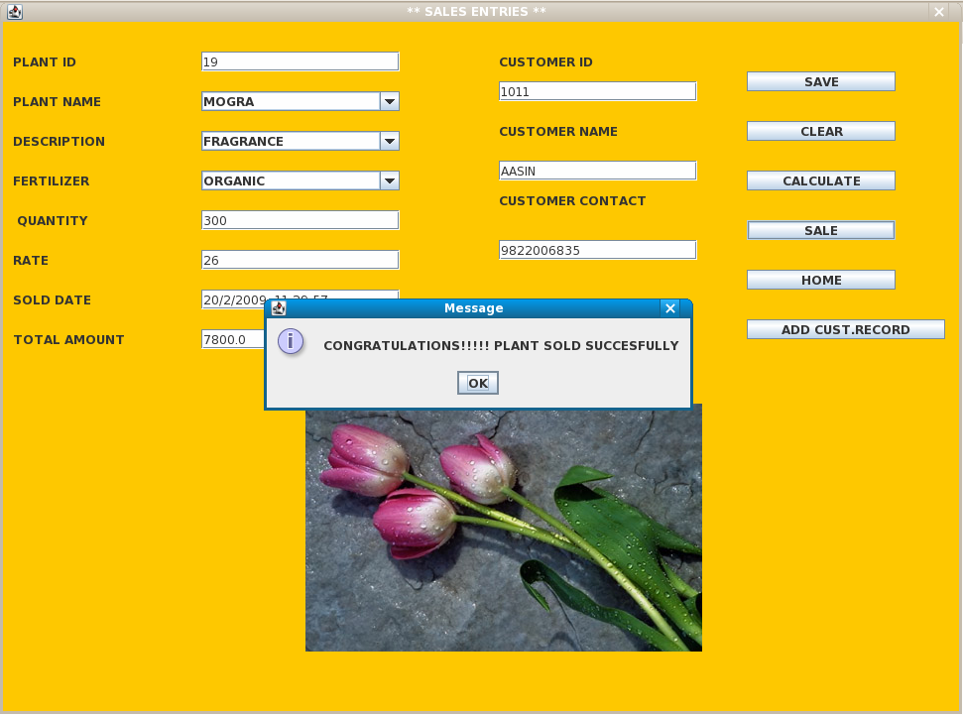

Plant sold successfully

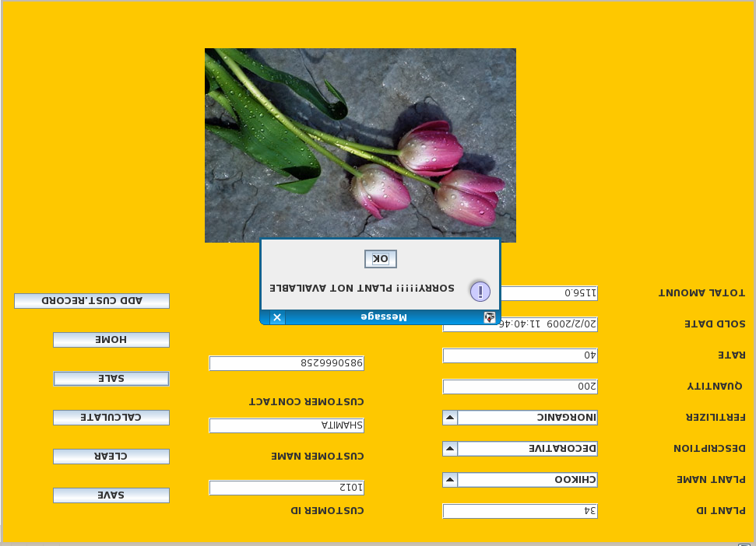

Plant not available in Nursary.

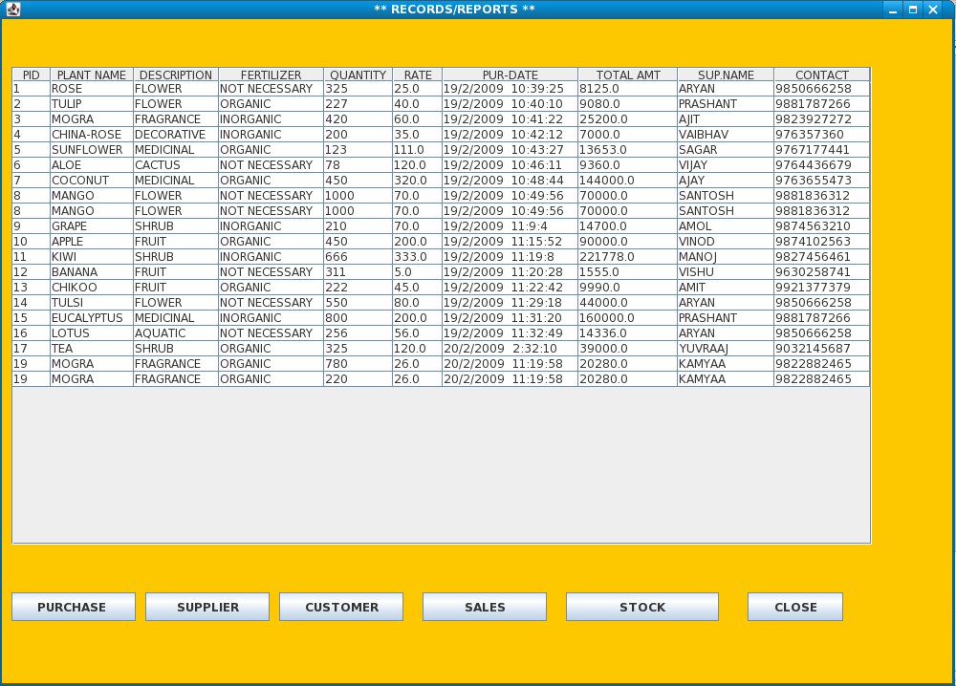

Purchase Record Stock Book.

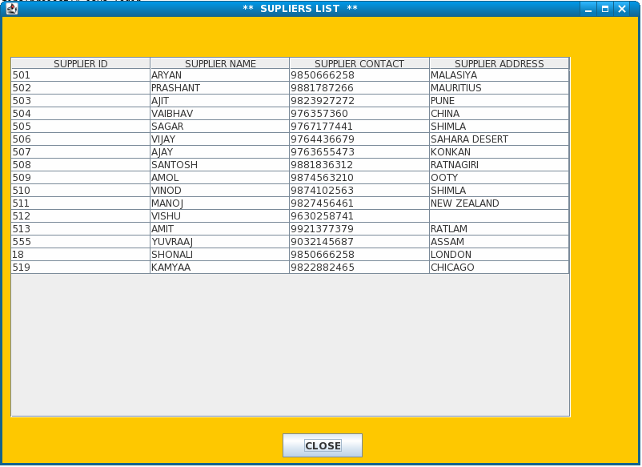

Supplier Record Stock Book.

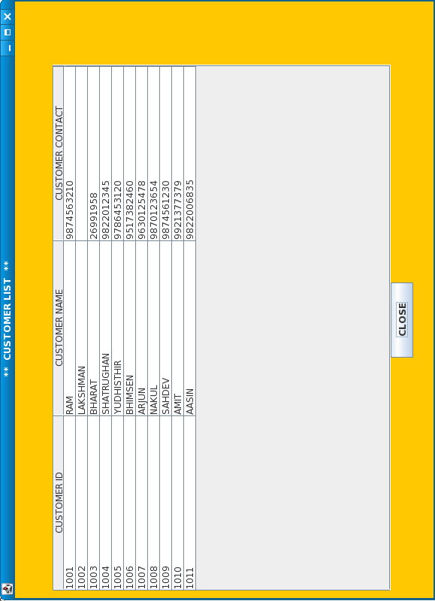

Customer Record Stock Book

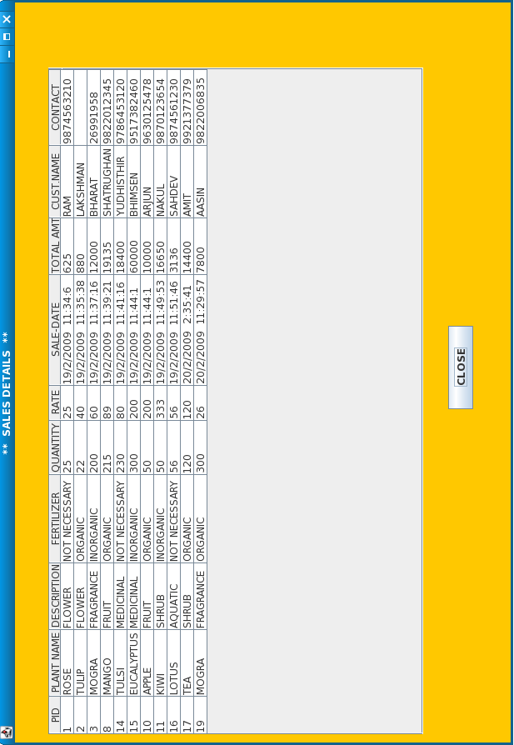

Sale Record Stock Book

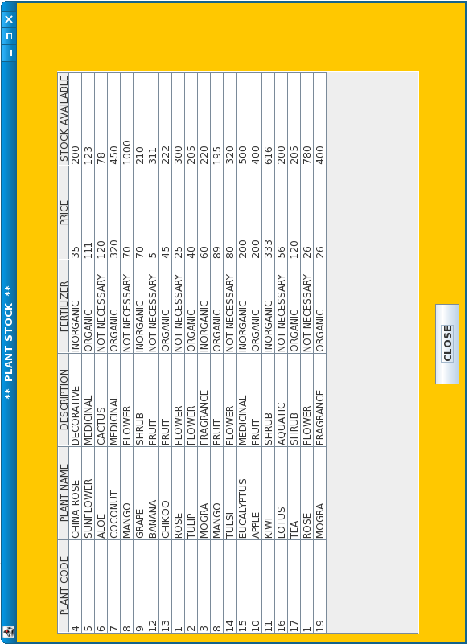

Plant Record Stock Book

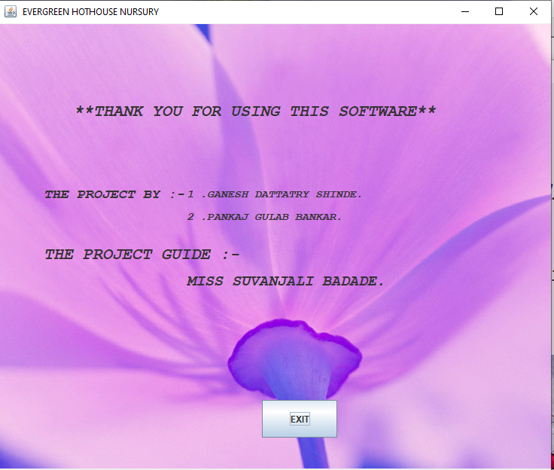

EXIT SCREEN

**8.CONCLUSION OF PROJECT**

It was really learning experience we have gained through this project.

This was a chance to implement theoretical knowledge into practical work and to test our ability.

**9. REFERENCE**

For the completion of our project and documentation we have referred the following plants:

1. Text Book of Java - Vision Publications

2. Complete reference of Java 2 - Herbert Schildt

3. Black Book. - Steven Hoizner

4. Text Book of Java - Nirali Publications

5. Software Engineering - Vision Publications